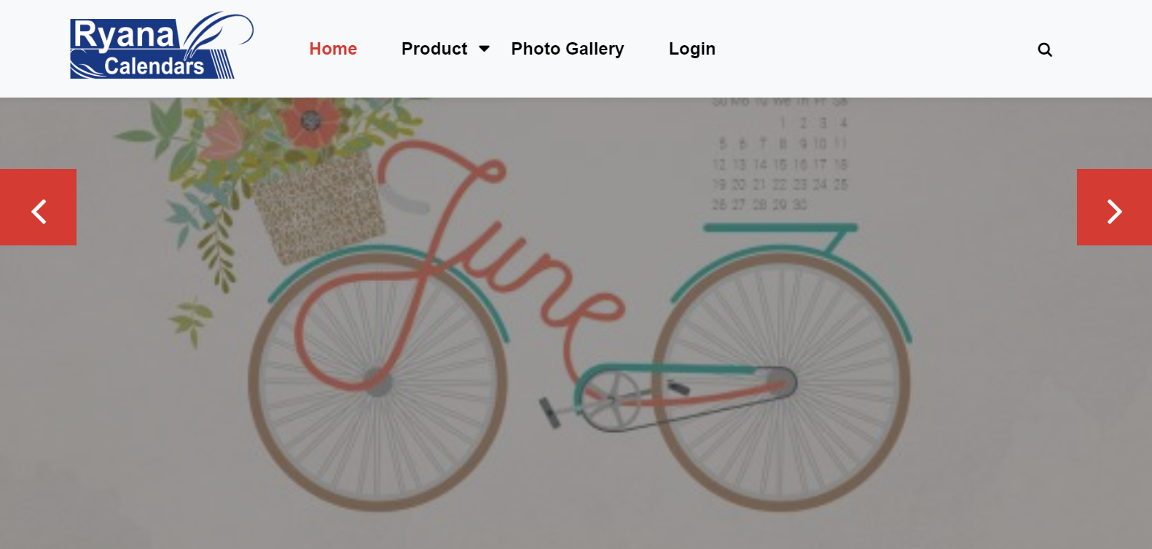

E project user guide

Faculty: Sir Owais Khan

**BATCH CODE: 2009G1**

**Ryana calender**

**PROJECT GROUP MEMBERS**

**. FAIZAN UL HASAN**

**.** Enrolment no:Student1274665

**.** Email: [fareedlov914@gmail.com](mailto:fareedlov914@gmail.com)

**.** **ABDULLAH NADEEM**

**.** Enrolment no:Student1274663

**.** Email: [m.diaz90676@gmail.com](mailto:m.diaz90676@gmail.com)

**.**  **SHAHAB KHAN**

**.** Enrolment no:Student1277144

**.** Email: [abdullahnadeem16@gmail.com](mailto:abdullahnadeem16@gmail.com)

**ACKNOWLEDGEMENT**

I would like to express our deepest appreciation to those who provided us the possibilities to complete the webpage. We would like to acknowledge with much appreciation the crucial role of **SIR OWAIS KHAN** who gave us the guidance to make the webpage. Who guided us through the work and improved our skills and gave us chance to be a part of **APTECH Institute** 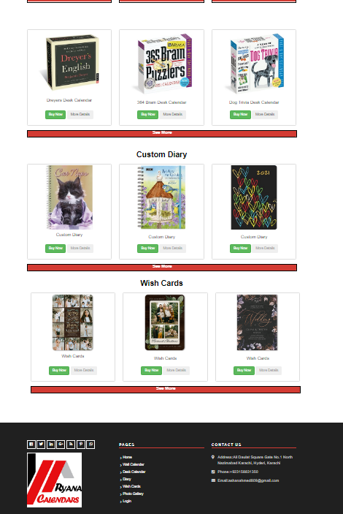****

**LOGIN PAGE**

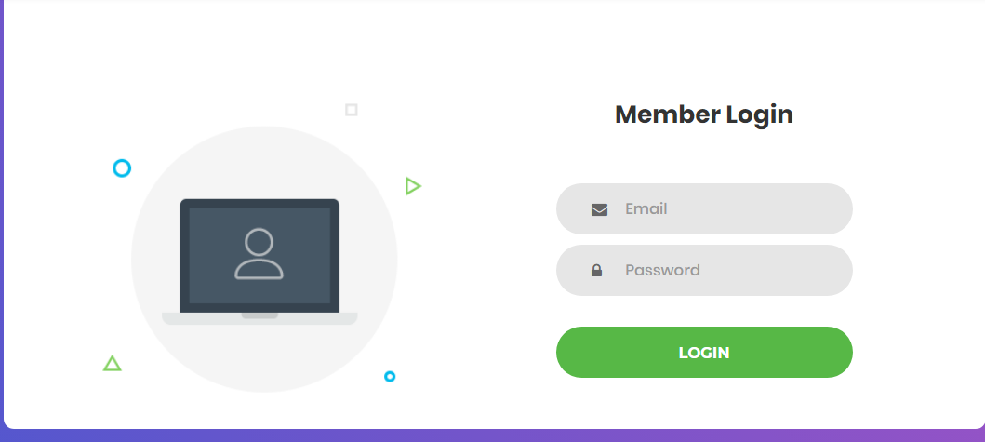

**Login page**

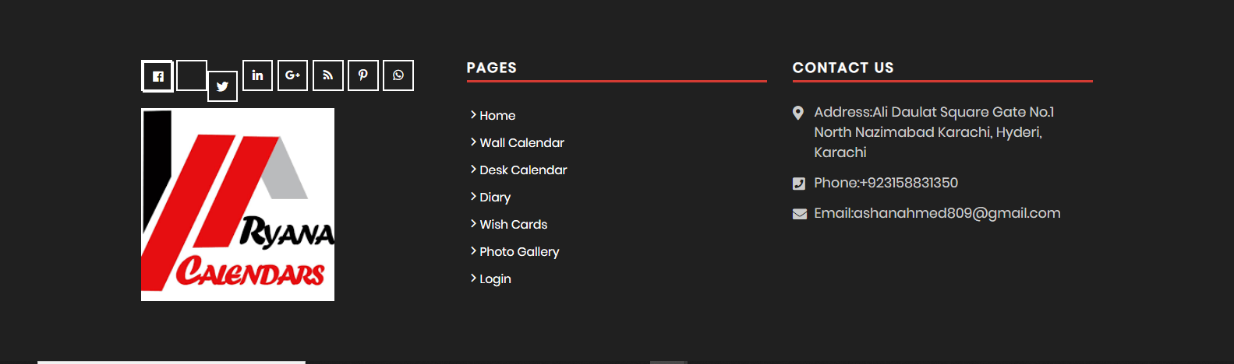

**FOOTER**